|  |
| --- |
| RAIDRIN  Macintosh HD:Users:AldrinJerome:Projects:SlotMachine:company_logo.png |
| KATIPUNERO SLOT MACHINE |
| **Freedom To Win!!!** |
| Version #1  All work Copyright © 2013 by Raidrin Games.  All rights reserved. |
| **Aldrin Jerome Almacin** |
|  |

|  |
| --- |
| June 1, 2013 |

**Table of Contents**

[Your Table of Contents should go here. Make sure that your document’s sections are hyperlinked to their corresponding pages.]

**Version History**

[This is where you keep track of the detailed changes made to your document throughout the course of development.]

1. **Game Overview**

*The game is a just a simple casino-style slot machine. The player is given starting money to play the game. The player will then play the game to earn more money. The game will continue until the user runs out of money or when the user quits the game. When run out of money, the user can decide to reset the game to play the game again with the starting money. The jackpot price also gets reset. The game icons are each item of a Katipunero (Filipino group who fought against Spain).*

1. **Game Play Mechanics**

*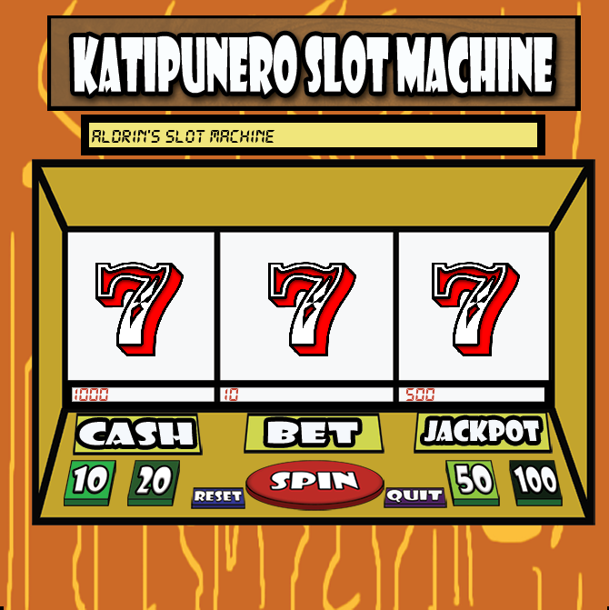*

*There are 4 bet buttons used to choose how much the user want to bet on a spin. Each button has a value (10, 20, 50, 100).*

*There is a spin button used to spin the reels. After the reels spin the user will know whether he win the game by looking at the message on top of the reels. If the user wants to see how much his cash, bet or the current jackpot is, he just needs to look at the texts under the reels. The user will have a chance to win the jackpot when he gets a pair of three symbols (excluding the sad faces). The machine will decide whether to give the jackpot price or not (1/100).*

1. **Controls**

*Mouse is used to click buttons or to click the close window.*

1. **Interface Sketch**

****

1. **Scoring**

*The odds of getting the icon in a reel and the win price are:*

|  |  |  |  |  |  |
| --- | --- | --- | --- | --- | --- |
| **Name** | **Image** | **Odds of getting one** | **Trio** | **Pair** | **Bonus Wins** |
| *Sad Face* | *Macintosh HD:Users:AldrinJerome:Projects:SlotMachine:images:sadface.png* | *40%* | *0* | *0* | *No sad face:*  *bet \* 1*  *(return bet)* |
| *Katipunero Hat* | *Macintosh HD:Users:AldrinJerome:Projects:SlotMachine:images:katipunero_hat.png* | *16%* | *Bet \* 10* | *Bet \* 1* | *n/a* |
| *Bandana* | *Macintosh HD:Users:AldrinJerome:Projects:SlotMachine:images:bandana.png* | *14%* | *Bet \* 20* | *Bet \* 2* | *n/a* |
| *Camesa De Chino* | *Macintosh HD:Users:AldrinJerome:Projects:SlotMachine:images:camesa_de_chino.png* | *12%* | *Bet \* 30* | *Bet \* 2* | *n/a* |
| *Banyal* | *Macintosh HD:Users:AldrinJerome:Projects:SlotMachine:images:banyal.png* | *7%* | *Bet \* 100* | *Bet \* 2* | *n/a* |
| *Tsinelas* | *Macintosh HD:Users:AldrinJerome:Projects:SlotMachine:images:tsinelas.png* | *6%* | *Bet \* 200* | *Bet \* 2* | *n/a* |
| *Arnis* | *Macintosh HD:Users:AldrinJerome:Projects:SlotMachine:images:arnis.png* | *4%* | *Bet \* 300* | *Bet \* 5* | *n/a* |
| *Siete* | *Macintosh HD:Users:AldrinJerome:Projects:SlotMachine:images:siete.png* | *1%* | *Bet \* 1000* | *Bet \* 10* | *One siete:*  *bet \* 5* |

1. **Bonuses**

**Winning the Jackpot:**

**After getting 3 icons in each reel excluding sad faces, the user will then have a chance to win the jackpot. The chance of winning (1/100)**

1. **Sound Index**

|  |  |
| --- | --- |
| **Name** | **Destination** |
| *Main background music (Paruparo ng bukid)* | *sounds/background\_msc.wav* |
| *Out of cash or invalid bet value* | *sounds/bet\_no\_cash\_snd.wav* |
| *Bet sound* | *sounds/bet\_snd.wav* |
| *Reset sound* | *sounds/reset\_snd.ogg* |
| *Spin/pull lever sound* | *sounds/spin\_snd.ogg* |
| *Spinning sound* | *sounds/spinning\_snd.ogg* |

1. **Art / Multimedia Index**

|  |  |
| --- | --- |
| **Name** | **Image** |
| **Images/arnis.png** | *Macintosh HD:Users:AldrinJerome:Projects:SlotMachine:images:arnis.png* |
| **Images/bandana.png** | *Macintosh HD:Users:AldrinJerome:Projects:SlotMachine:images:bandana.png* |
| **Images/banyal.png** | *Macintosh HD:Users:AldrinJerome:Projects:SlotMachine:images:banyal.png* |
| **Images/camesa\_de\_chino.png** | *Macintosh HD:Users:AldrinJerome:Projects:SlotMachine:images:camesa_de_chino.png* |
| **Images/fifty\_button.png** | **Macintosh HD:Users:AldrinJerome:Projects:SlotMachine:images:fifty_button.png** |
| **Images/hundred\_button.png** | **Macintosh HD:Users:AldrinJerome:Projects:SlotMachine:images:hundred_button.png** |
| **Images/katipunero\_hat.png** | *Macintosh HD:Users:AldrinJerome:Projects:SlotMachine:images:katipunero_hat.png* |
| **Images/quit\_button.png** | **Macintosh HD:Users:AldrinJerome:Projects:SlotMachine:images:quit_button.png** |
| **Images/reset\_button.png** | **Macintosh HD:Users:AldrinJerome:Projects:SlotMachine:images:reset_button.png** |
| **Images/sadface.png** | *Macintosh HD:Users:AldrinJerome:Projects:SlotMachine:images:sadface.png* |
| **Images/siete.png** | *Macintosh HD:Users:AldrinJerome:Projects:SlotMachine:images:siete.png* |
| **Images/spin\_button.png** | **Macintosh HD:Users:AldrinJerome:Projects:SlotMachine:images:spin_button.png** |
| **Images/ten\_button.png** | **Macintosh HD:Users:AldrinJerome:Projects:SlotMachine:images:ten_button.png** |
| **Images/tsinelas.png** | *Macintosh HD:Users:AldrinJerome:Projects:SlotMachine:images:tsinelas.png* |
| **Images/twenty\_button.png** | **Macintosh HD:Users:AldrinJerome:Projects:SlotMachine:images:twenty_button.png** |

1. **Design Notes**

*Design made at home.*

1. **Future Features**

*Add a jackpot win game. Show hundred boxes and the user will choose one. One of the boxes have jackpot.*

*Sound on/off.*

*Win sound and lose sound.*